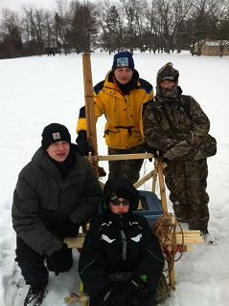
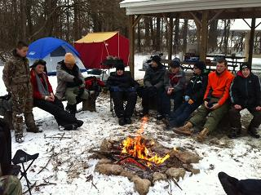
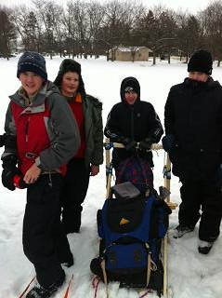
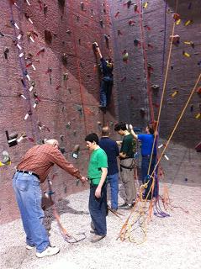
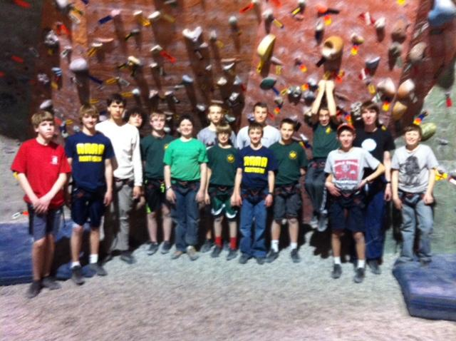
Urban Krag
On February 8 -9, we went to Urban Krag to go rock climbing. There were 15 scouts on the trip. There were also 5 adults belay certified.We started the evening by rock climbing. Then we ate some pizza and had two rock climbing competitions. Chris won both of the competitions.
Klondike
Klondike happened at Camp Birch on January 25 – 27.
Upcoming Events:
Merit Badge Trail Drive #3 – March 2
Scouting For Food – March 9 & 16
Elections – March 11
TLT – April 8
Scouting Skills/COPE Campout – April 19 - 21
January and February 2013 Newsletter

